**Installing SQL Server Guide**

**Notes: Disable windows Firewall**

click **Setup.exe**.

[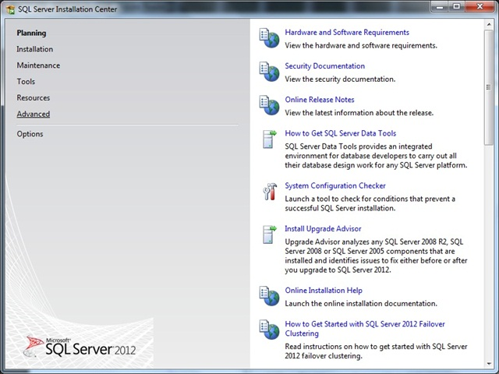](http://basitaalishan.files.wordpress.com/2012/06/012.jpg)

[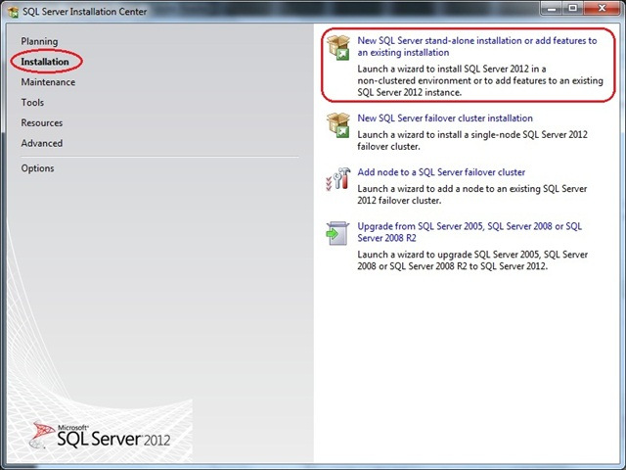](http://basitaalishan.files.wordpress.com/2012/06/021.jpg)

Setup is now preparing to launch Setup Support Rules window:

[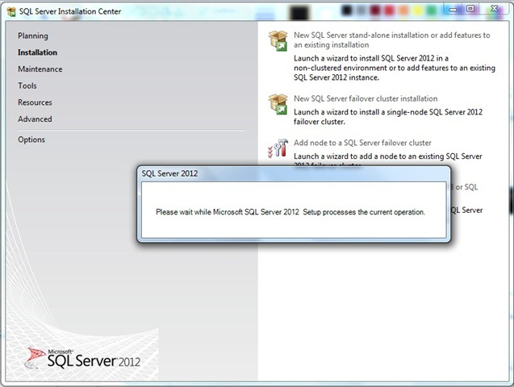](http://basitaalishan.files.wordpress.com/2012/06/031.jpg)

Now Setup Support Rules will run to identify problems that may occur during the Setup Support Files installation:

[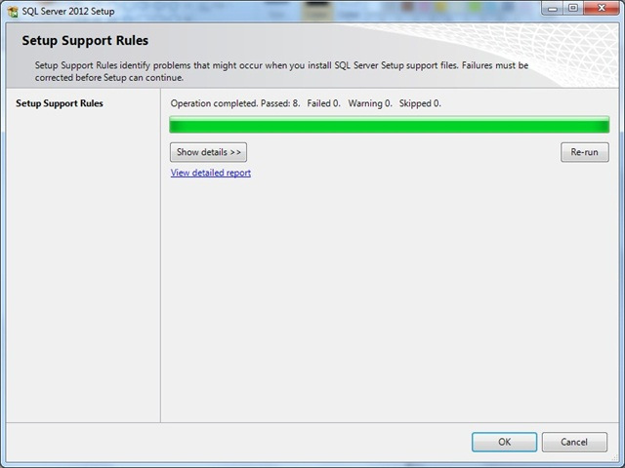](http://basitaalishan.files.wordpress.com/2012/06/041.jpg)

Once this step finishes click **OK** to proceed to Product Key window, In the Product Key window, enter the Product license key (if required), and click **Next** to continue:

[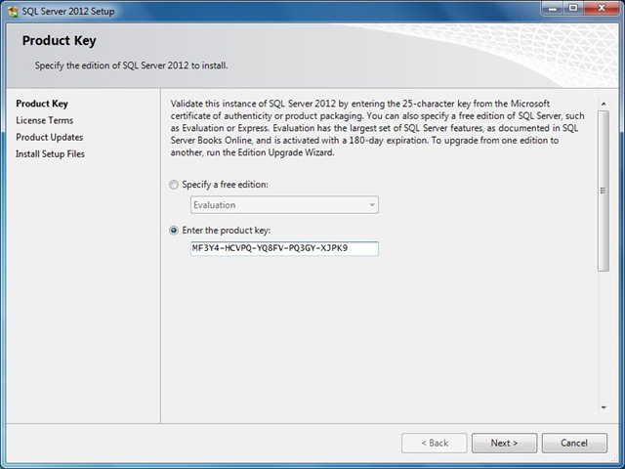](http://basitaalishan.files.wordpress.com/2012/06/051.jpg)

In the License Terms window, tick the box I accept the license terms and then click **Next** to continue:

[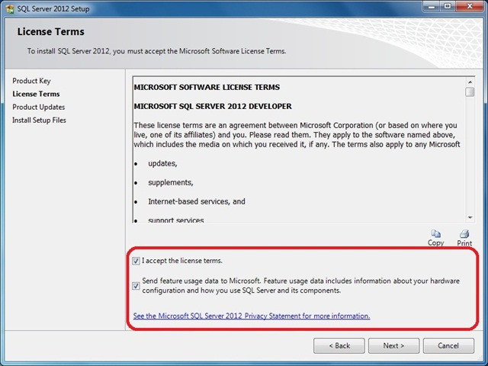](http://basitaalishan.files.wordpress.com/2012/06/061.jpg)

[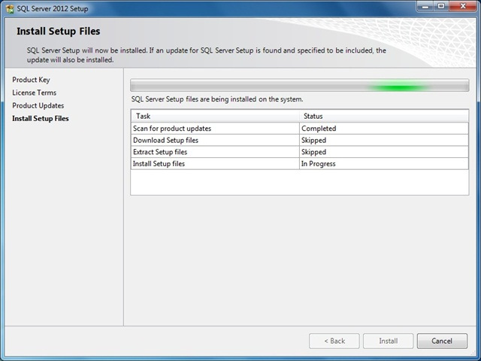](http://basitaalishan.files.wordpress.com/2012/06/071.jpg)

These files are necessary to perform the actual installation. Following the installation of the setup support files, you will be presented with another compatibility check. Following dialog appears once you successfully pass these checks. You can click the **Show Details** button under the green progress bar if you want to see the individual checks listed:

[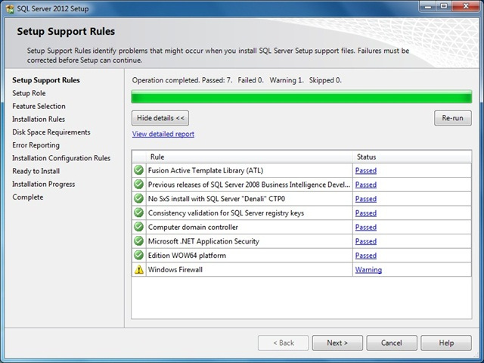](http://basitaalishan.files.wordpress.com/2012/06/081.jpg)

Click**Next** to continue to the Setup Role page:

[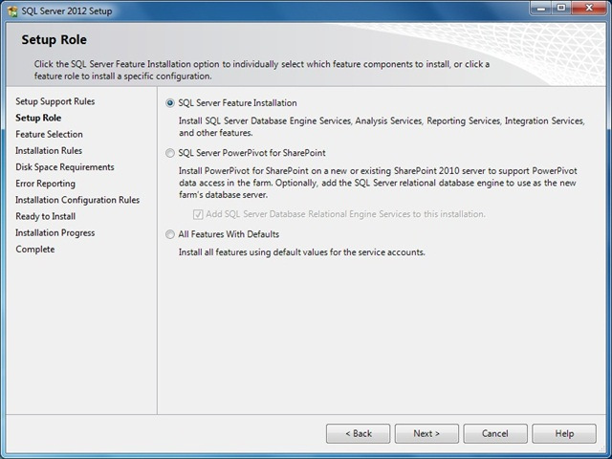](http://basitaalishan.files.wordpress.com/2012/06/091.jpg)

Select **SQL Server Feature Installation** option and then**Next** to continue to Feature Selection page:

[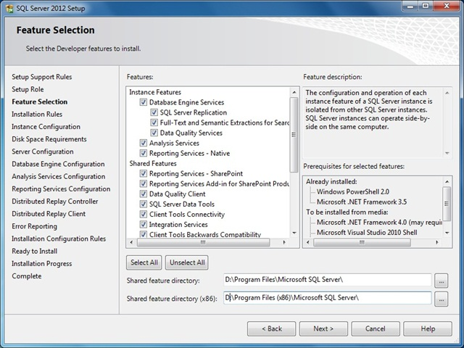](http://basitaalishan.files.wordpress.com/2012/06/102.jpg)

Choose Default instance

[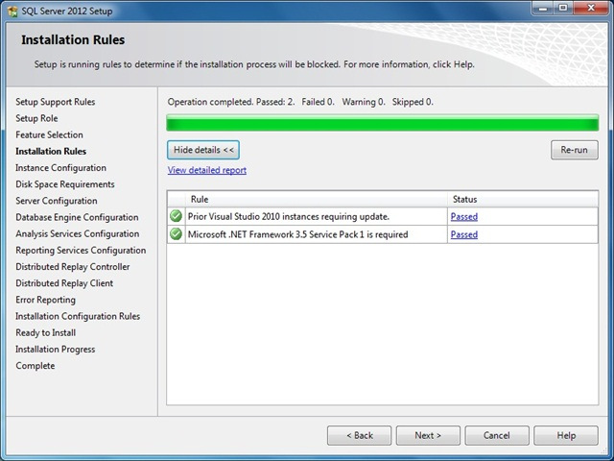](http://basitaalishan.files.wordpress.com/2012/06/111.jpg)

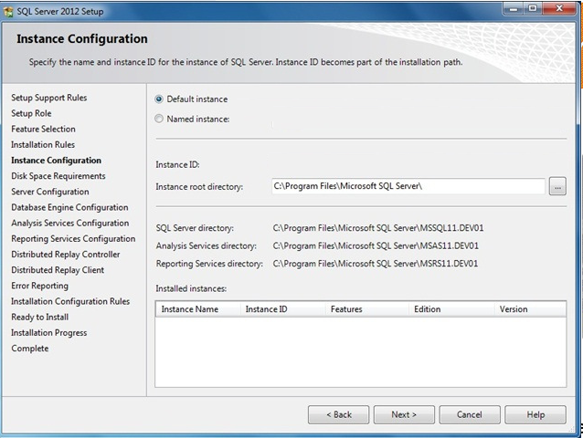

***Note: This screen also report on other instances installed on this machine.***

Click **Next** to proceed to the Disk Space Requirements page:

[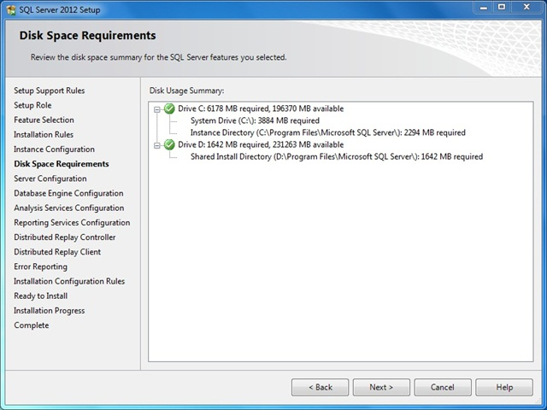](http://basitaalishan.files.wordpress.com/2012/06/131.jpg)

This is just a information page that does not require you to make any choices. Click **Next** to go to Server Configuration page:

[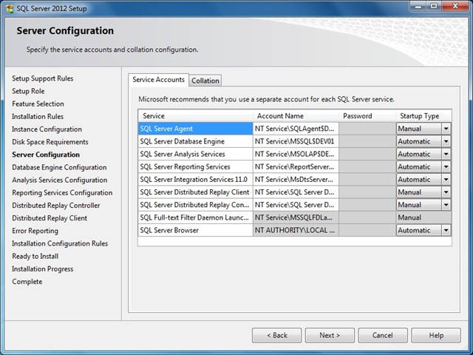](http://basitaalishan.files.wordpress.com/2012/06/141.jpg)

Choose “Mixed Mode Authentication”. You will also need to specify the SQL Server administrators to be used; in this example I will use the current logged in user by clicking **Add Current User** button:

[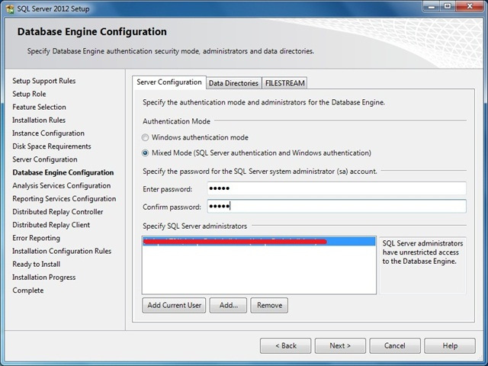](http://basitaalishan.files.wordpress.com/2012/06/171.jpg)

Click FILESTREAM tab and enable this feature as below:

[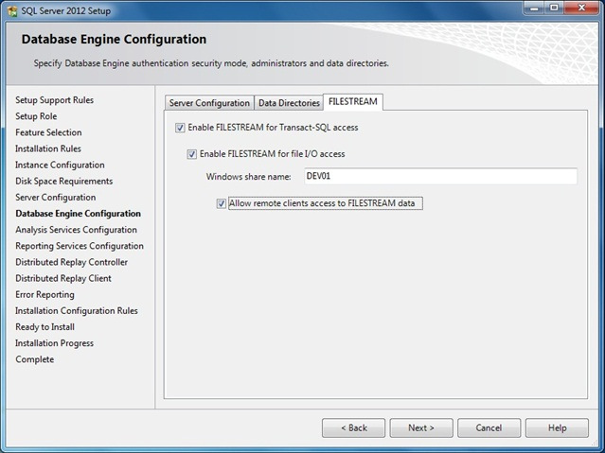](http://basitaalishan.files.wordpress.com/2012/06/191.jpg)

FILESTREAM feature is quiet useful when binaries or other data that does not fit neatly in a table structure.

Click **Next** to proceed to Analysis Services Configuration page, this is similar to Database Engine Configuration page.

Specify users or accounts that will have administrator permissions for Analysis Services in Account Provisioning page and specify non-default installation directories in Data Directories page:

[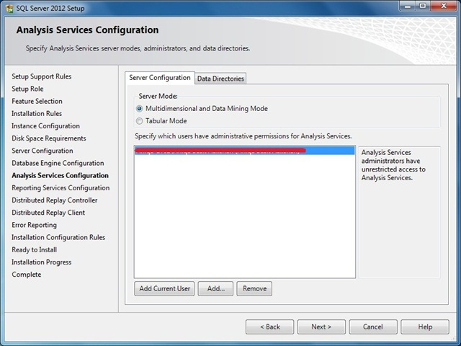](http://basitaalishan.files.wordpress.com/2012/06/202.jpg)

Click Next to continue to Reporting Services Configuration page, specify the kind of Reporting Services installation to create. For the purpose of this article, I will use Install and Configure option:

[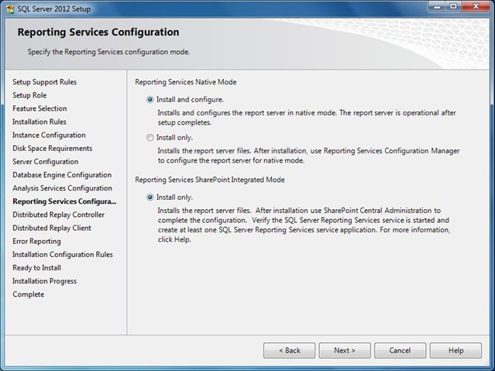](http://basitaalishan.files.wordpress.com/2012/06/221.jpg)

*For more information about Reporting Services configuration modes and the options we have, see*[*Reporting Services Configuration Options (SSRS)*](http://msdn.microsoft.com/en-us/library/ms144292.aspx)*.*

Click **Next** to proceed to Distributed Replay Controller page, specify the users you want to grant administrative permissions to for the Distributed Replay controller service and then click Next to continue:

[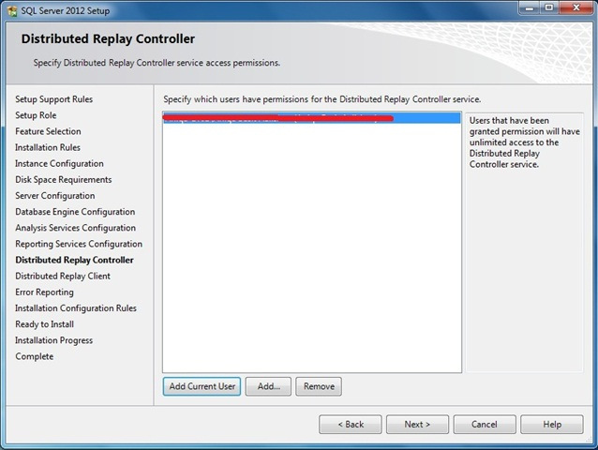](http://basitaalishan.files.wordpress.com/2012/06/231.jpg)

Distributed Replay Client Configuration page appears, here specify setting as shown in next figure:

[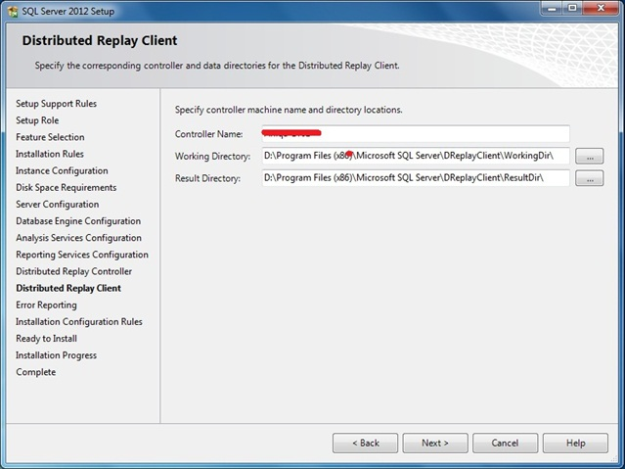](http://basitaalishan.files.wordpress.com/2012/06/242.jpg)

Click **Next** to advanced to Error Reporting page, tick the check box if you want to send Windows and SQL Server error reports to Microsoft:

[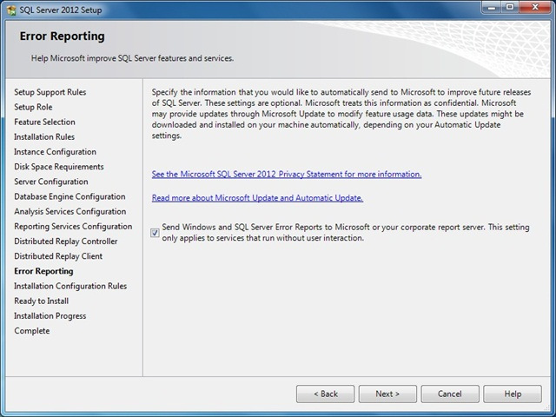](http://basitaalishan.files.wordpress.com/2012/06/251.jpg)

Click **Next**, Now System Configuration Checker will run some more rules that will validate your computer configuration with the SQL Server features you have specified:

[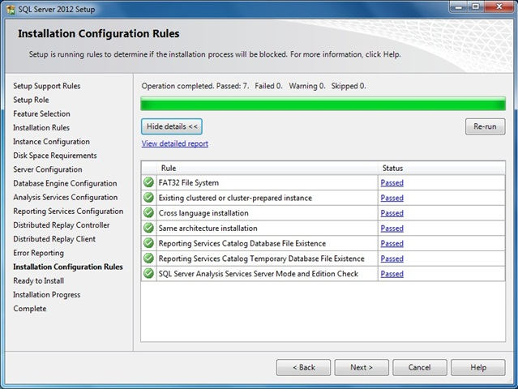](http://basitaalishan.files.wordpress.com/2012/06/261.jpg)

Correct any errors reported in the Installation Rules screen and click on **Next** to advanced to Ready to Install page. This page shows a tree view of installation options that were specified during Setup. On this page, Setup indicates whether the Product Update feature is enabled or disabled and the final update version:

[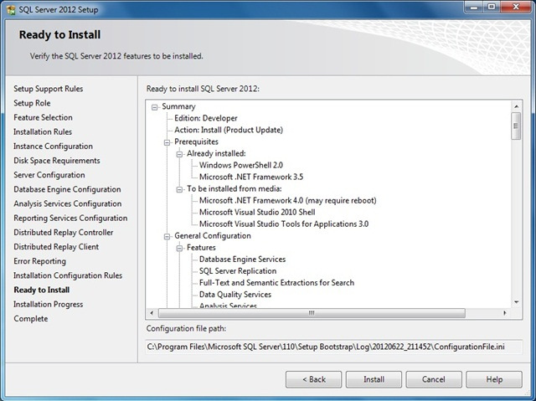](http://basitaalishan.files.wordpress.com/2012/06/271.jpg)

Click **Install** button to start SQL Server 2012 installation. The Setup will first install the required prerequisites for the selected features followed by the feature installation. The Installation Progress page provides status so that you can monitor installation progress as Setup continues:

[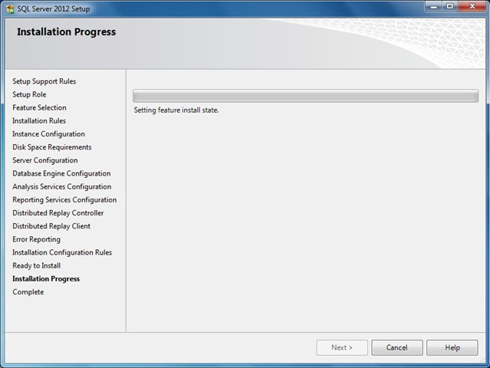](http://basitaalishan.files.wordpress.com/2012/06/281.jpg)

When the installation is complete, click on **Next** to Complete page:

[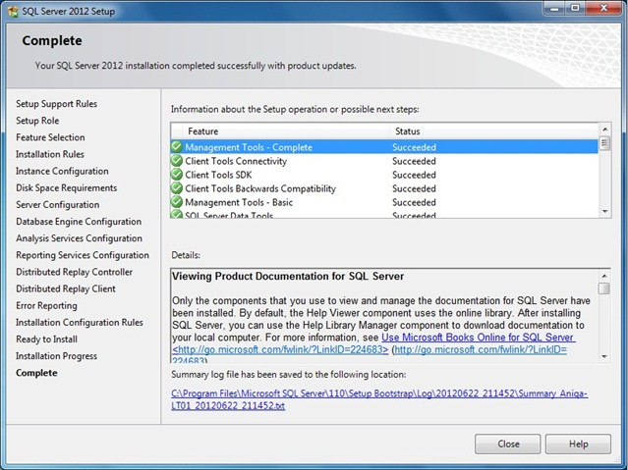](http://basitaalishan.files.wordpress.com/2012/06/291.jpg)

Click on the link to review the installation log if appropriate, then click on **Close**.

This finalizes the installation process for SQL Server 2012.